Increasing Tiny Data Imputation Accuracy Using Temporal Polynomial Interpolation

Ikke Dian Oktaviani
School of Computing
Telkom University
Bandung, Indonesia
idoktaviani@student.telkomuniversity.ac.id
Maman Abdurohman
School of Computing
Telkom University
Bandung, Indonesia
abdurohman@telkomuniversity.ac.id
Bayu Erfianto
School of Computing
Telkom University
Bandung, Indonesia
erfianto@telkomuniversity.ac.id

Abstract— Missing data is a common case in many systems. Incomplete data can affect the accuracy of analysis results. There are several methods have been proposed to handle missing data. Commonly, the way to recover the data is by eliminating the incomplete data series or replacing it with the average value of existing or previous data. This paper proposes a more accurate imputing incomplete data using the temporal polynomial interpolation method for tiny data such as live data. The result shows quadratic interpolation method generally gives fairly accurate results compared to other polynomial interpolation methods, with an MSE value of 0.051 for 10% missing data, 0.033 for 30% missing data, and 0,035 for 50% missing data. This MSE result is still better than another method like simple regression, which has an MSE value for 10% missing data around 0.71, 30% missing data around 0.59, and 50% missing data around 0.44.
Keywords—missing data, incomplete data, interpolation, tiny data

INTRODUCTION
Missing data is one of the obstacles often found in the system. Incomplete data occurs due to several factors, such as system disturbances, unstable internet networks in the data communication process, and decreased sensor function. In the data analysis process, such data conditions can certainly be an obstacle, one of which is in the realm of big data. The presence of missing data can interfere with the data learning process, affecting the results of data analysis [1]. In time-series data, the completeness of the data is crucial, so it is necessary for the data analysis process. Some of the needs in data analysis are forecasting, monitoring, and others.
In some cases, completeness of data is required quickly on a running system. The internet of things (IoT) based system is an example of a system that often experiences problems with incomplete data conditions and requires a solution to complete the missing data [2]. The process of completing the missing data is called the data imputation process.
The data imputation process consists of various ways, such as deleting missing data [3], filling in the data with the average value of the entire existing data, and so on [4], [5]. Several researchers have applied the data imputation process in various cases. [6], [7] are examples of cases of implementing data imputation. Research [6] imputed data in the medical field with patient data, and [7] carried out data imputation on weather time series data. The research shows that cases that experience missing data have a fairly wide area.
Our main contributions are summarized as follows:
- We present a more accurate system with a short execution time for imputing tiny data such as live data using the temporal polynomial interpolation method. We have implemented the interpolation method in an application using tiny live data.
- We have compared and classified the suitable interpolation method for tiny data. We compare three types of interpolation methods and get the best one among them.
This paper consists of several sections. Section I is the introduction part that talks about the background of the research to be carried out. Section II describes previous research on data imputation. Section III contains the research flow as well as the methods used. Section IV discusses the experimental research results. The last section is section V which is the conclusion of the research.

RELATED WORK
Several previous studies have shown that the application of methods to overcome missing data is in the big data area. The solutions offered are diverse regarding the data type, methods, and research objectives. Applying conventional and the latest methods, such as artificial intelligence (AI), can solve the missing data problem. Research [3] describes various methods to impute data referring to the percentage of missing data. Unfortunately, this paper does not contain conventional interpolation-based methods for data imputation. Most only review AI methods for data imputation, of course, in a large enough amount of data.
Research conducted by [8] applies a method based on a generative adversarial network (GAN) to perform data imputation. Given that GAN is part of deep learning, the amount of data greatly affects the study results. Unlike the case with [9], which uses various methods to impute data, from simple statistical calculation methods to overcome the problem of single data imputation to calculation methods by going through a learning process to perform multiple data imputation. The results obtained depend on the percentage of missing data. In addition, a study [10] shows that the data imputation problem can be solved using interpolation combined with K-Nearest Neighbours (k-NN). With linear interpolation based, the result of the research has an improvement compared with their baseline. As we know, implementating the AI method needs many data. A lack of data can give a bad result for predicting.
Other studies that contain data imputation problems are [11] and[10], [12]. [11] show that interpolation can help predict air pollution data between two sensor stations. The spatial interpolation used is a natural cubic spline and gives a good result to predict the value. The research output is a heatmap containing many colors to show the level of air pollution. The colors represent the value of the interpolation process. However, using a spatial element for imputing data has a big-time complexity because there are two interpolate processes. Besides that, [12] imputed data in spatio-temporal cases with a fairly diverse percentage of missing data using the cokriging method. Because cokriging is a kind of kriging interpolation, it should have a big time complexity like [11], and it also uses spatial elements for interpolate process.

POLYNOMIAL INTERPOLATION METHOD

System Design
Briefly, figure 1 describes the system design to overcome the problem of missing data by imputing data. The dataset used for this research is time-series data with a tiny data type consisting of 60 data within 60 minutes. Tiny data is the main problem raised in this study. The available data is then processed to find the Nan value in it. If there is no Nan result, there is no data imputation process; if there is Nan data, then the data imputation process must be carried out. The process of imputing data through several methods, including conventional methods consisting of linear, quadratic, and cubic interpolation.

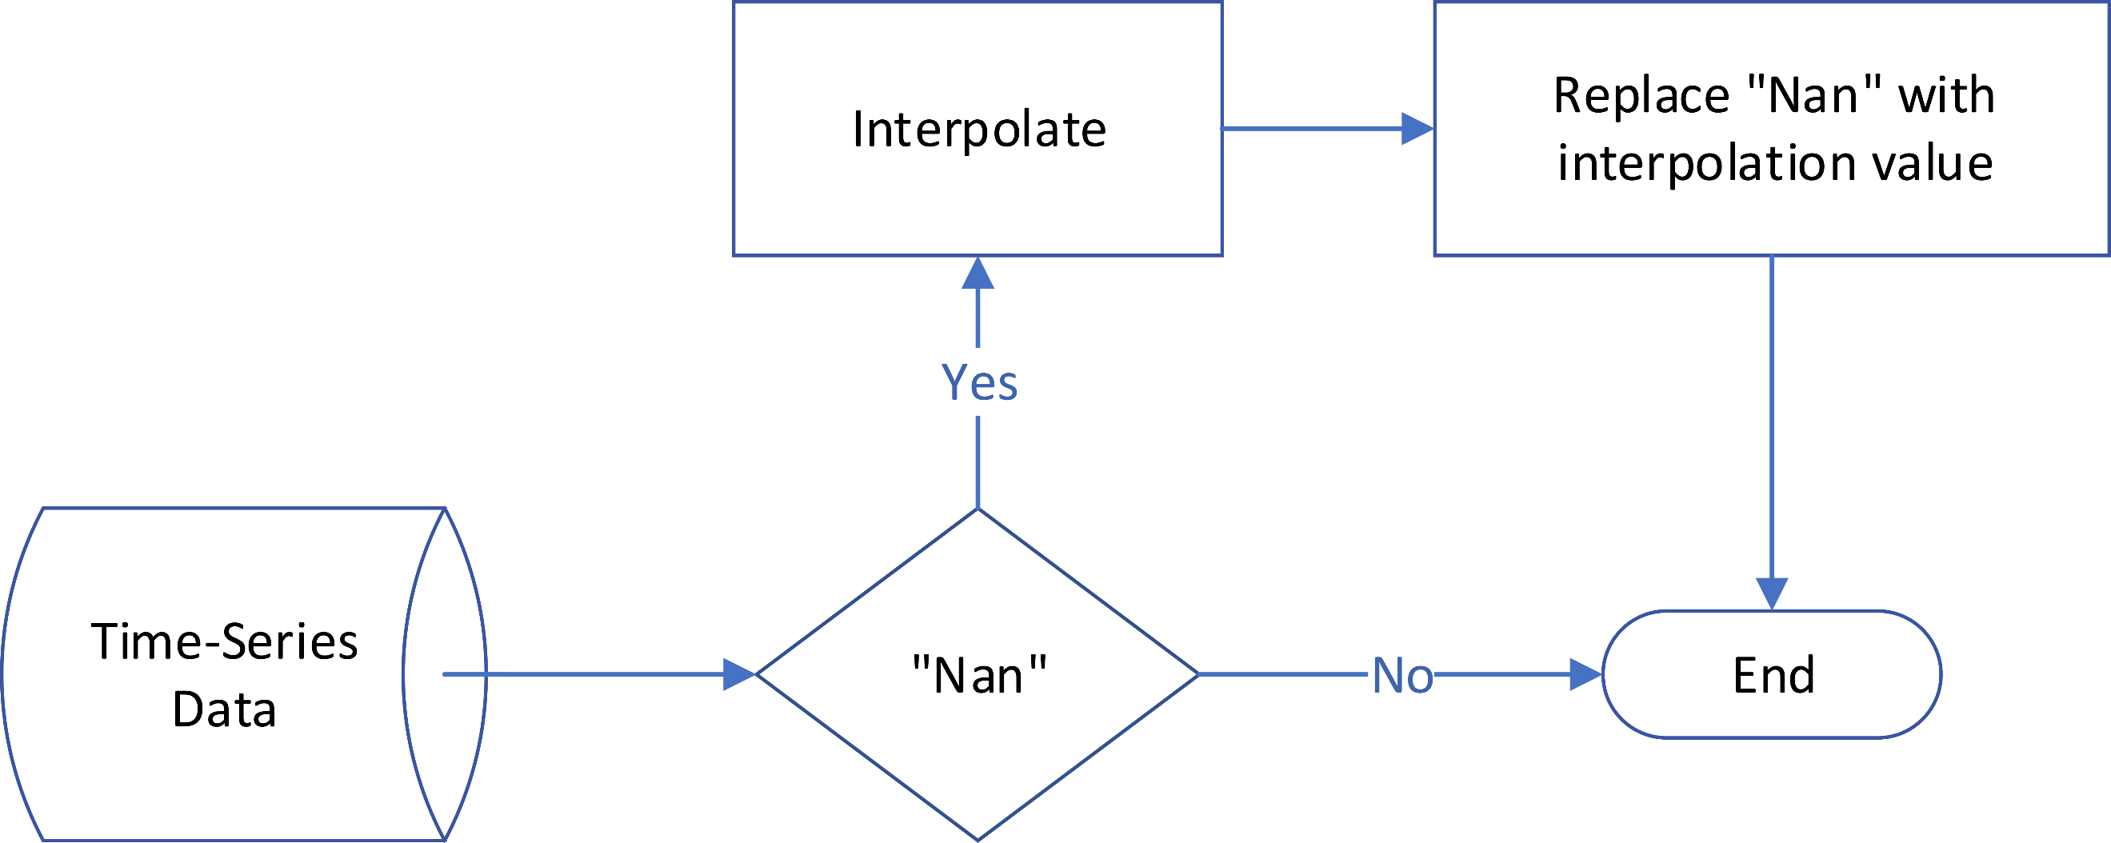

FIGURE 1. DATA IMPUTATION PROCESS DIAGRAM
Each interpolation undergoes a different calculation process. If there is more than one missing data, then the thing to do when interpolating is in many ways:
- Ignore other Nan values that can affect the process.
- Use the best value between linear and quadratic interpolation values to calculate cubic interpolation.
- Replace the Nan value with a previously known value if the Nan value is between the extrapolation points. In other words, the Nan value was at the beginning or end of the data list.
Therefore, linear interpolation can greatly affect the results of quadratic and cubic interpolation calculations.

Interpolation
There are several types of interpolation. Linear interpolation is a pioneer in the emergence of interpolation, whose calculation method is very simple and easy to understand. Over time, interpolation underwent various kinds of development. Interpolation is a method to find a value at a point among other points that already have a value [13]. With the development of interpolation, this method is often related to spatial and temporal-based cases.
In polynomial-based interpolation, linear interpolation is a method of finding the value at a point between two previously known points with a polynomial that interpolates to the degree of one or using a line equation. Besides linear interpolation, there is quadratic interpolation. This method uses three reference points to find the value at a point between the three with a polynomial that interpolates to the degree of two. The last polynomial method is cubic interpolation which involves four points in calculating the value search at a point between the four with a polynomial that interpolates to the degree of three [14].

FIGURE 2. INTERPOLATION CLASSIFICATION
Easily, interpolating polynomials with each other undergoes a process of perfecting the results. Based on its equations, the method with higher-order polynomials will involve lower-order polynomials. Therefore, the higher the degree of the applied polynomial, the more polynomial interpolation is assumed to have better results.

RESULT AND DISCUSSION
At the experimental stage, the process was to apply interpolation with the most basic interpolation, namely linear interpolation. The data used in this experiment is a dataset that contains sensor data for measuring air temperature. Air temperature has a significant change every minute.
Based on the experiments on the interpolation methods, interpolation can give quite good results on tiny time series-based data. Equation (1) was the equation of linear interpolation
$$f_{1}(x)=y_{0}+\frac{\left(x-x_{0}\right)}{\left(x_{1}-x_{0}\right)}×(y_{1}-y_{0})$$ | (1)
where $x_{0}$ and $x_{1}$ are reference values independent variables from a known point between x, the reference point of the value that want to find out. $f_{1}(x)$ was the dependent variable whose value you want to know between $y_{0}$ and $y_{1}$, which already has a value[15].
$$f_{2}\left(x\right)=f_{1}\left(x\right)+$$  $$\frac{\frac{y_{2}-y_{1}}{x_{2}-x_{1}}-\frac{y_{1}-y_{0}}{x_{1}-x_{0}}}{\left(x_{2}-x_{0}\right)}×(x-x_{0})×(x-x_{1})$$ | (2)
Equation (2) was an equation of quadratic interpolation involving new points $x_{2}$ and $y_{2}$, and equation (3) cubic interpolation added x3 and y3 points.
$$f_{3}\left(x\right)=f_{2}\left(x\right)+$$  $$\frac{\frac{y_{3}-y_{2}}{x_{3}-x_{2}}-\frac{y_{2}-y_{1}}{x_{2}-x_{1}}-\frac{y_{1}-y_{0}}{x_{1}-x_{0}}}{\left(x_{3}-x_{0}\right)}×$$  $$(x-x_{0})×(x-x_{1})×(x-x_{2})$$ | (3)
In its implementation, generating missing data is carried out randomly, with the percentage of missing data at 10%, 30%, and 50 from the data used. Because the data is of a tiny data type, adding 10% missing data can greatly impact the value prediction results. The smaller the percentage of missing data, the higher the accuracy value in the data imputation process. In addition, the position of the missing data can affect the prediction results. The distribution of missing data in one dataset illustrates the difference in results—the random location of missing data at the data’s beginning, middle, or end. If the missing data position is in the middle, it will make the prediction results quite accurate, assuming the values between them are known. On the other hand, if the missing data position is at the dataset's beginning and end, the accuracy percentage decreases drastically.
This research focuses on the temporal element because the independent variable contains time data. Many interpolation methods use a spatial element to interpolate the data. However, this research wants to show that the result of the interpolation method that does not contain a spatial element can give good accuracy and spatial interpolation method.
In some cases, the method that gives fairly good prediction results is linear interpolation. On other occasions, quadratic interpolation can give accurate results equal to the true value. Unfortunately, cubic interpolation cannot outperform linear and quadratic interpolation as expected because it has poor average accuracy when imputing single or multiple data.
TABLE 1. MSE OF EACH METHOD TYPES
Missing Value Percentage | Linear | Quadratic | Cubic | Type of Methods
10% | 0.083 | 0.051 | 0.123 | Type A
30% | 0.034 | 25.205 | 157.364 | Type A
 | - | 25.204 | 157.369 | Type B
 | - | 0.033 | 0.069 | Type C
 | - | 0.314 | 0.074 | Type D
50% | 0.062 | 15.146 | 143.124 | Type A
 | 0.188 | 15.138 | 94.448 | Type B
 | - | 0.043 | 0.262 | Type C
 | - | 0.035 | 0.050 | Type D

MSE is a metric for reviewing predictive data results. The implementation was by applying these metrics to each dataset used. Table 1 shows each method's MSE value and the calculation process's type.
The MSE of type A and type B was relatively high because the Nan value is at the end of the data list. The interpolation method gave the best result when all the known points were in interpolated range. If there is one known point outside the interpolated area, it will affect the output drastically. Because of that, type A and type B in quadratic and cubic interpolation have a bad result for MSE value rather than the other type. The solution used the data before the Nan value if the Nan value is at the data beginning or end. Types C and D represent this condition for dealing with types A and B.
Figure 3 illustrates the graph of the measurement results against the predicted results of 10% missing data from 60 data using linear, quadratic, and cubic interpolation. These results show that quadratic interpolation tends to be stable in giving fairly accurate results compared to linear and cubic interpolation. In the case of imputed data with random missing data positions, the result with the best accuracy was when the missing data position was in the middle. Each variable for the calculation process has a value.
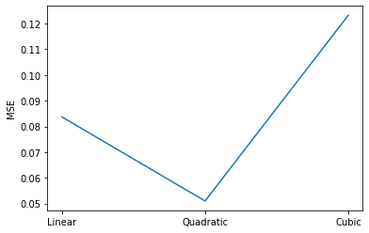
FIGURE 3. 10% MISSING DATA MSE
When the percentage of missing data changes to 30%, the accuracy value changes in some calculation types. Figure 4 shows that type A and type B always give a worse accuracy result than the other type. Same as before, quadratic interpolation has a better MSE value compared to other methods.

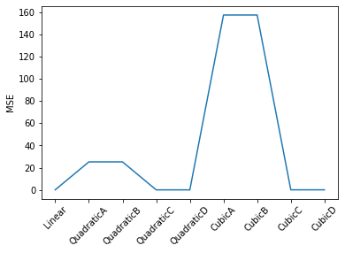
Figure 4. 30% MISSING DATA MSE
When the percentage of missing data changes to 50%, the accuracy value does not change drastically. With a fairly large percentage, losing 5 out of 10 data causes the possibility of missing data positions at the beginning and end of the data. Loss of data at the initial position of the dataset can produce a prediction value of 0, so the accuracy obtained is far from accurate. The position of missing data at the end of the dataset can also provide far from accurate predictions. These things can happen because x and y have no value, so they are both 0 and happen in type A and type B.
Interpolation can be done and gives good results when all the values used are in the interpolated range. When values are out of scope, the possible process to achieve acceptable accuracy was applying extrapolation methods. Figure 6 shows the graph of MSE of all interpolation calculation, excluding type A and type B, which has extrapolated range value.

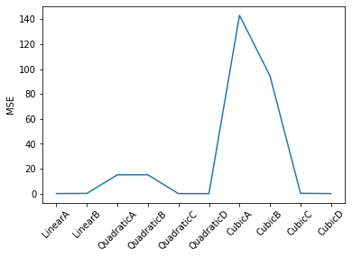
FIGURE 5.MSE 5% MISSING DATA
Quadratic interpolation always gives the best results, as seen in figure 7, because it has a proportion of the use of variables that tends to be more balanced than linear and cubic interpolation. Cubic interpolation that uses more variables cannot guarantee that the resulting value will be more accurate. This result occurs because there was a process that involves linear and quadratic interpolation values into the cubic interpolation equation so that the average prediction result with cubic interpolation is higher than the actual value.
From this research, the result shows that temporal polynomial interpolation has good accuracy for data imputation. With a small MSE value, the predicting data error rate was also low. However, the temporal polynomial interpolation method will result badly when the Nan value is between the extrapolation range data (outside range). This disadvantage will apply to all interpolation methods, which is a big problem for the interpolation process. However, solving this problem by combining with another imputation method like imputing with the current value.

conclusion
Data imputation, which is the process of completing data, is important considering data loss can be an obstacle in data analysis. In performing data imputation, the method's implementation adjusts to the data's characteristics, the amount of data, and the percentage of missing data in a dataset. The percentage of missing data of 10%, 30%, and 50% can give quite contrasting results between one dataset and another. This research shows that quadratic interpolation has a good result when applied to impute data with single and multiple missing data with an MSE value of 0.051 for 10% missing data, 0.033 for 30% missing data, and 0,035 for 50% missing data. Cubic polynomial interpolation, expected to give higher accuracy, gives a bad result compared to linear interpolation. Future work in this research is to apply spline interpolation because it assumes that the interpolation can give better results than polynomial interpolation or increase the amount of data used. Research in tiny data for missing data problems still needs to be done, considering that research on missing data is currently mostly applied to big data types.
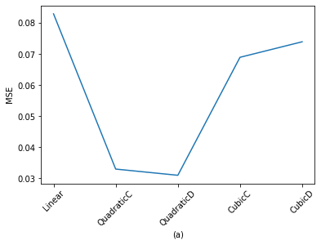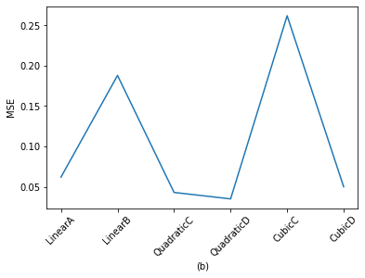
FIGURE 6. (a) 30% MISSING DATA MSE VALUE WITH TYPE C AND D; (b) 50% MISSING DATA MSE VALUE WITH TYPE C AND D

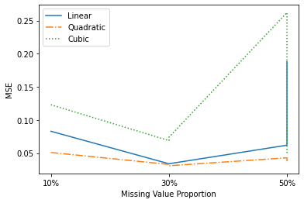
Figure 7. ACCURACY COMPARISON

ACKNOWLEDGMENT
We would like to thank Telkom University for financial support for this research. We also thank to Aji Gautama Putrada, Sidik Prabowo, and Ihsan Fajar Nurzaman for all the insights for this research.

References
[1] R. C. Pereira, M. S. Santos, P. P. Rodrigues, and P. H. Abreu, “Reviewing Autoencoders for Missing Data Imputation: Technical Trends, Applications and Outcomes,” Journal of Artificial Intelligence Research, vol. 69, pp. 1255–1285, Dec. 2020, doi: 10.1613/JAIR.1.12312.
[2] I. Izonin, N. Kryvinska, R. Tkachenko, and K. Zub, “An approach towards missing data recovery within IoT smart system,” Procedia Computer Science, vol. 155, no. 2, pp. 11–18, 2019, doi: 10.1016/J.PROCS.2019.08.006.
[3] M. S. Osman, A. M. Abu-Mahfouz, and P. R. Page, “A Survey on Data Imputation Techniques: Water Distribution System as a Use Case”, doi: 10.1109/ACCESS.2018.2877269.
[4] K. M. Lang and T. D. Little, “Principled Missing Data Treatments,” Prevention Science 2016 19:3, vol. 19, no. 3, pp. 284–294, Apr. 2016, doi: 10.1007/S11121-016-0644-5.
[5] T. Emmanuel, T. Maupong, D. Mpoeleng, T. Semong, B. Mphago, and O. Tabona, “A survey on missing data in machine learning,” Journal of Big Data 2021 8:1, vol. 8, no. 1, pp. 1–37, Oct. 2021, doi: 10.1186/S40537-021-00516-9.
[6] S. Islam Khan and A. Sayed Md Latiful Hoque, “SICE: an improved missing data imputation technique Background and related works,” vol. 7, p. 37, 2020, doi: 10.1186/s40537-020-00313-w.
[7] E. Afrifa-Yamoah, | U A Mueller, | S M Taylor, and | A J Fisher, “Missing data imputation of high-resolution temporal climate time series data,” 2020, doi: 10.1002/met.1873.
[8] D. T. Neves, M. G. Naik, and A. Proença, “SGAIN, WSGAIN-CP and WSGAIN-GP: Novel GAN Methods for Missing Data Imputation,” Lecture Notes in Computer Science (including subseries Lecture Notes in Artificial Intelligence and Lecture Notes in Bioinformatics), vol. 12742 LNCS, pp. 98–113, 2021, doi: 10.1007/978-3-030-77961-0_10/COVER/.
[9] A. Jadhav and D. Pramod & Krishnan Ramanathan, “Comparison of Performance of Data Imputation Methods for Numeric Dataset,” Applied Artificial Intelligence, vol. 33, no. 10, pp. 913–933, 2019, doi: 10.1080/08839514.2019.1637138.
[10] S. Daberdaku, E. Tavazzi, and B. di Camillo, “A Combined Interpolation and Weighted K-Nearest Neighbours Approach for the Imputation of Longitudinal ICU Laboratory Data,” Journal of Healthcare Informatics Research, vol. 4, no. 2, pp. 174–188, Jun. 2020, doi: 10.1007/S41666-020-00069-1.
[11] I. D. Oktaviani, B. Erfianto, and A. Rakhmatsyah, “Air pollution distribution in Telkom University: Spatial interpolation map,” Journal of Physics: Conference Series, vol. 1192, no. 1, May 2019, doi: 10.1088/1742-6596/1192/1/012013.
[12] B. Bae, H. Kim, H. Lim, Y. Liu, L. D. Han, and P. B. Freeze, “Missing data imputation for traffic flow speed using spatio-temporal cokriging,” Transportation Research Part C: Emerging Technologies, vol. 88, pp. 124–139, Mar. 2018, doi: 10.1016/J.TRC.2018.01.015.
[13] E. Kreyszig, Advanced Engineering Mathematics, 10th ed. New York: Laurie Rosatone. [Online]. Available: www.ieee.org.
[14] S. C. Chapra and R. P. Canale, Numerical methods for engineers. McGraw-Hill Higher Education, 2010.
[15] N. M. Noor, M. M. al Bakri Abdullah, A. S. Yahaya, and N. A. Ramli, “Comparison of linear interpolation method and mean method to replace the missing values in environmental data set,” Materials Science Forum, vol. 803, pp. 278–281, 2015, doi: 10.4028/WWW.SCIENTIFIC.NET/MSF.803.278.

IEEE conference templates contain guidance text for composing and formatting conference papers. Please ensure that all template text is removed from your conference paper prior to submission to the conference. Failure to remove template text from your paper may result in your paper not being published

